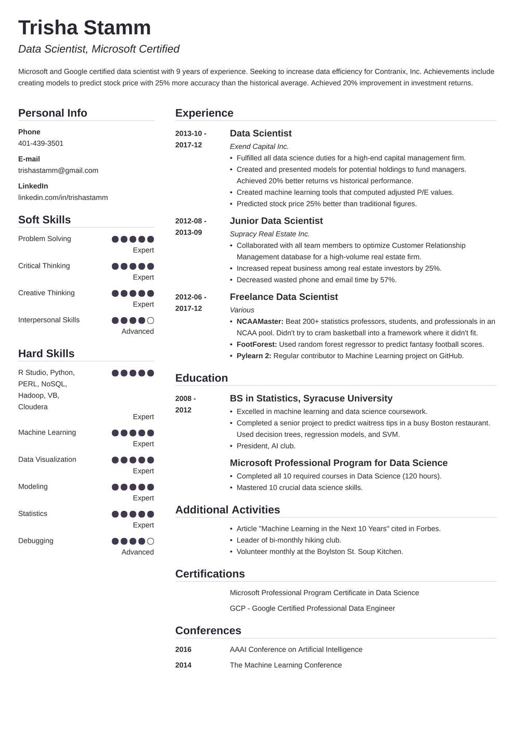
Trisha Stamm
Data Scientist, Microsoft Certified
Microsoft and Google certified data scientist with 9 years of experience. Seeking to increase data efficiency for Contranix, Inc. Achievements include creating models to predict stock price with 25% more accuracy than the historical average. Achieved 20% improvement in investment returns.
Personal Info
Phone
401-439-3501
E-mail
trishastamm@gmail.com
LinkedIn
linkedin.com/in/trishastamm
Experience
2013-10-
2017-12
2012-08- 2013-09
Soft Skills
Problem Solving
Expert
Critical Thinking
Expert
Creative Thinking
Expert
2012-06- 2017-12
Interpersonal Skills
Advanced
Hard Skills
R Studio, Python,
PERL, NOSQL,
Hadoop, VB,
Cloudera
Education
2008 -
2012
Expert
Machine Learning
Expert
Data Visualization
Expert
Expert
Statistics
Expert
Modeling
Debugging
Advanced
Data Scientist
Exend Capital Inc.
• Fulfilled all data science duties for a high-end capital management firm.
• Created and presented models for potential holdings to fund managers. Achieved 20% better returns vs historical performance.
• Created machine learning tools that computed adjusted P/E values.
• Predicted stock price 25% better than traditional figures.
Junior Data Scientist
Supracy Real Estate Inc.
• Collaborated with all team members to optimize Customer Relationship Management database for a high-volume real estate firm.
• Increased repeat business among real estate investors by 25%.
• Decreased wasted phone and email time by 57%.
Freelance Data Scientist
Various
• NCAAMaster: Beat 200+ statistics professors, students, and professionals in an NCAA pool. Didn't try to cram basketball into a framework where it didn't fit.
⚫ FootForest: Used random forest regressor to predict fantasy football scores.
• Pylearn 2: Regular contributor to Machine Learning project on GitHub.
BS in Statistics, Syracuse University
• Excelled in machine learning and data science coursework.
• Completed a senior project to predict waitress tips in a busy Boston restaurant. Used decision trees, regression models, and SVM.
• President, Al club.
Microsoft Professional Program for Data Science
• Completed all 10 required courses in Data Science (120 hours). Mastered 10 crucial data science skills.
Additional Activities
• Article "Machine Learning in the Next 10 Years" cited in Forbes.
• Leader of bi-monthly hiking club.
• Volunteer monthly at the Boylston St. Soup Kitchen.
Certifications
Microsoft Professional Program Certificate in Data Science GCP - Google Certified Professional Data Engineer
Conferences
2016
AAAI Conference on Artificial Intelligence
2014
The Machine Learning Conference

